**Nama : Adian Safrida**

**Tugas Membuat Query Bagian 2**

1. **SELECT * FROM ‘apotek’ ORDER BY jenis_produk DESC**

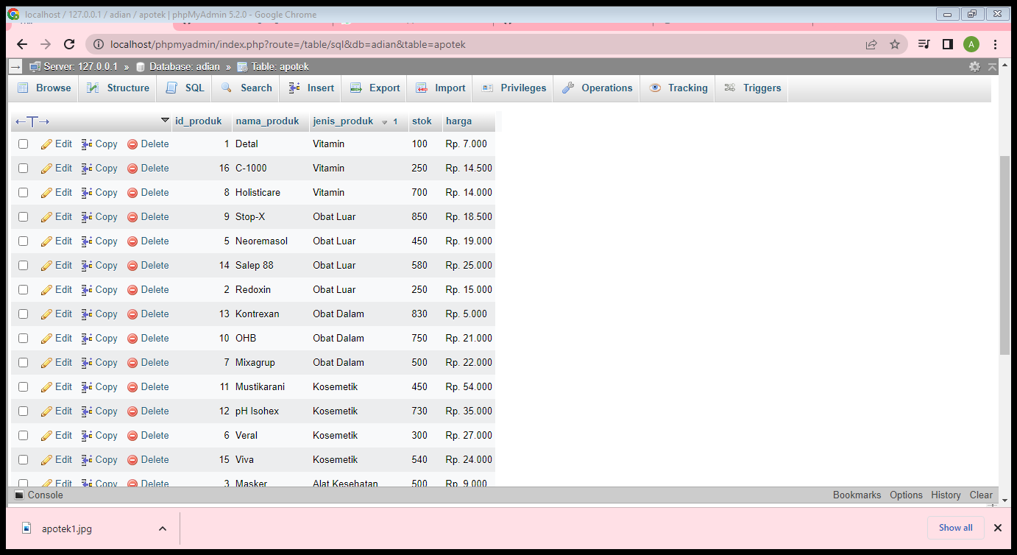

1. **SELECT * FROM ‘apotek’ ORDER BY nama_produk ASC**

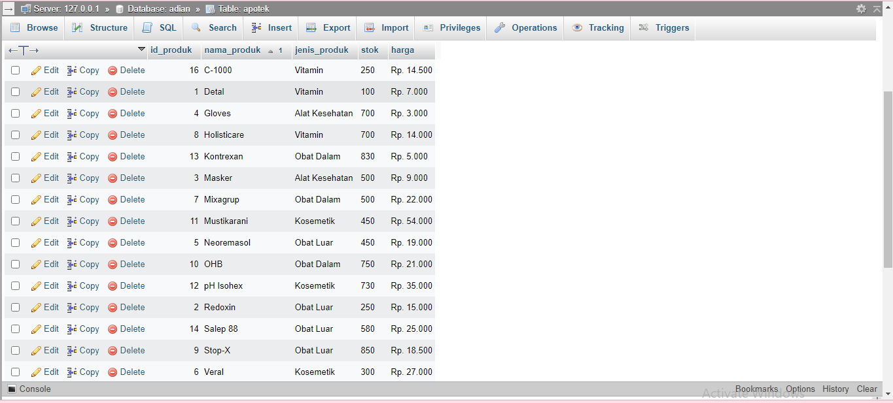

1. **SELECT * FROM ‘apotek’ WHERE jenis_produk LIKE ‘%Obat Dalam%’**

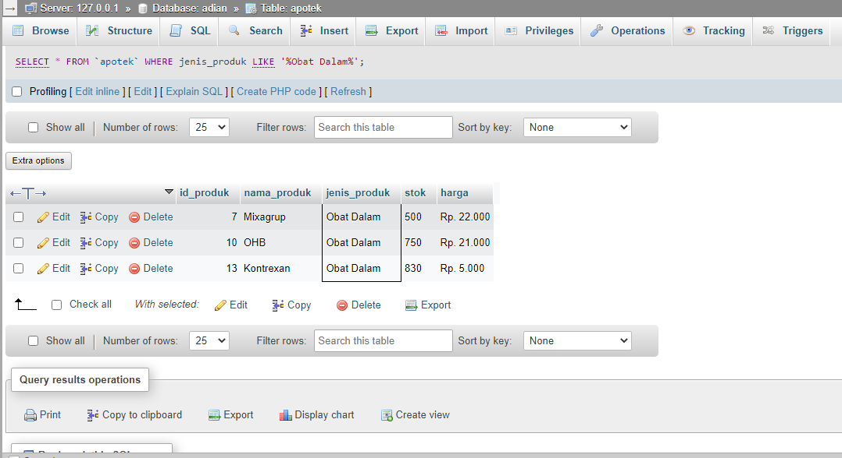

1. **SELECT * FROM ‘apotek’ WHERE jenis_produk LIKE ‘%Vitamin%’**

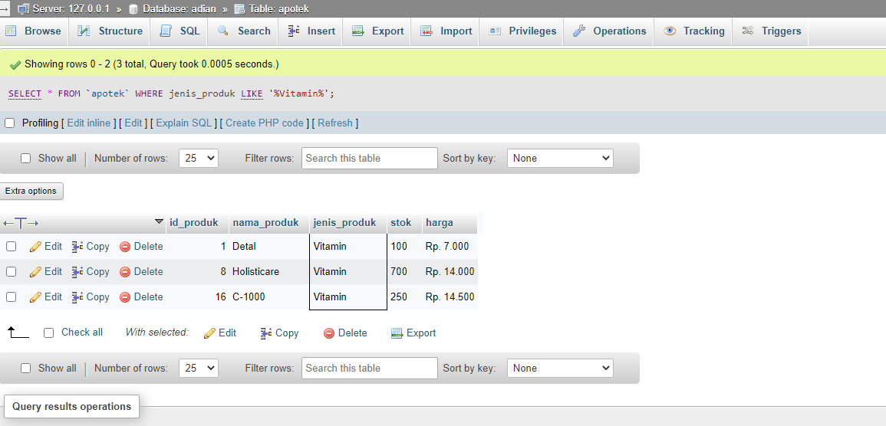

1. **SELECT jenis_produk, SUM(stok) AS total FROM ‘apotek’ GROUP BY jenis_produk**

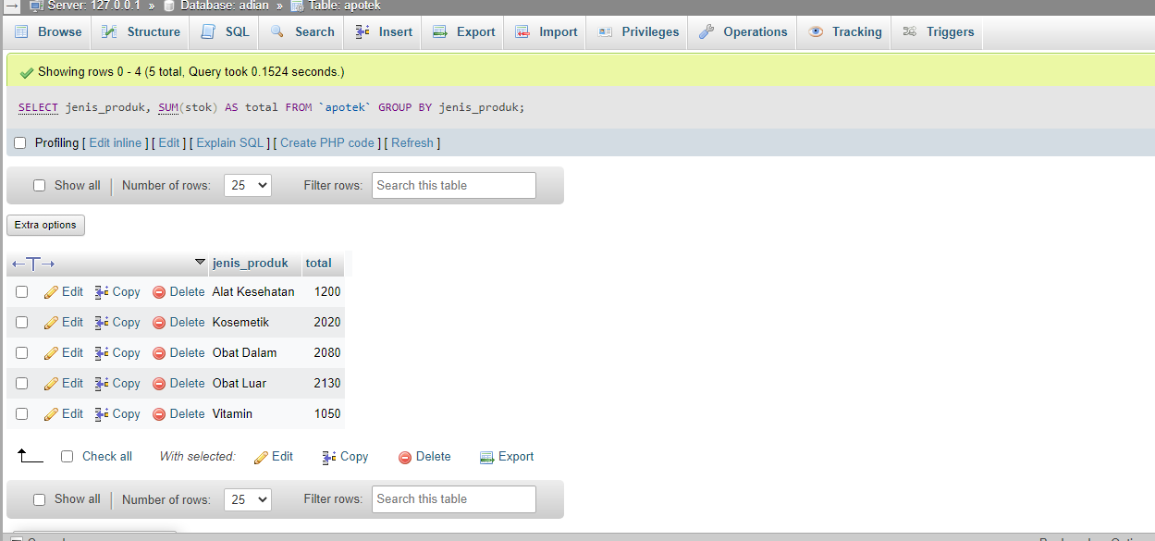

1. **SELECT tahun, SUM(stok) AS total FROM ‘apotek’ GROUP BY tahun**

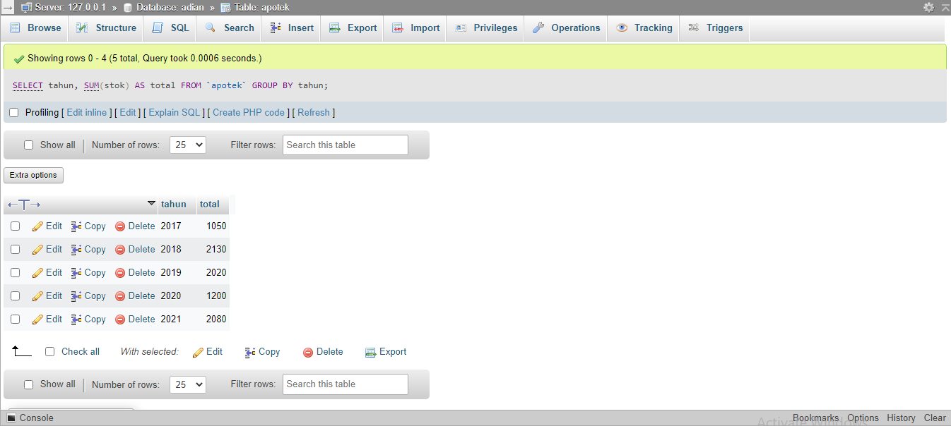

1. **SELECT kode, SUM(stok) AS total FROM ‘apotek’**

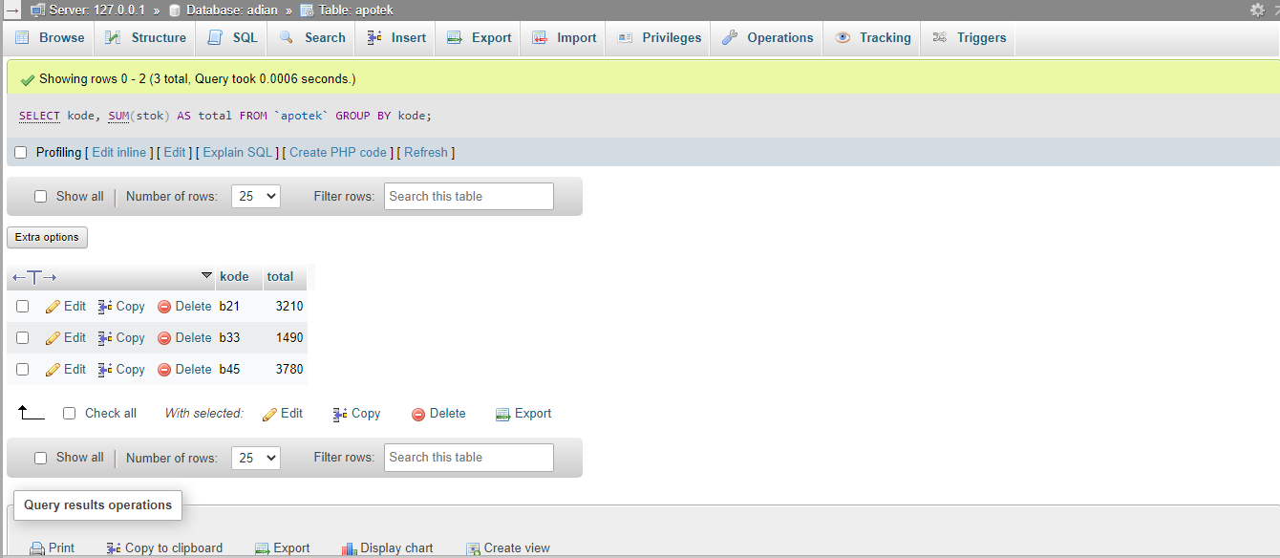

1. **SELECT tahun, SUM(stok) AS total FROM ‘apotek’ WHERE tahun >= 2018 GROUP BY tahun ORDER BY tahun DESC**

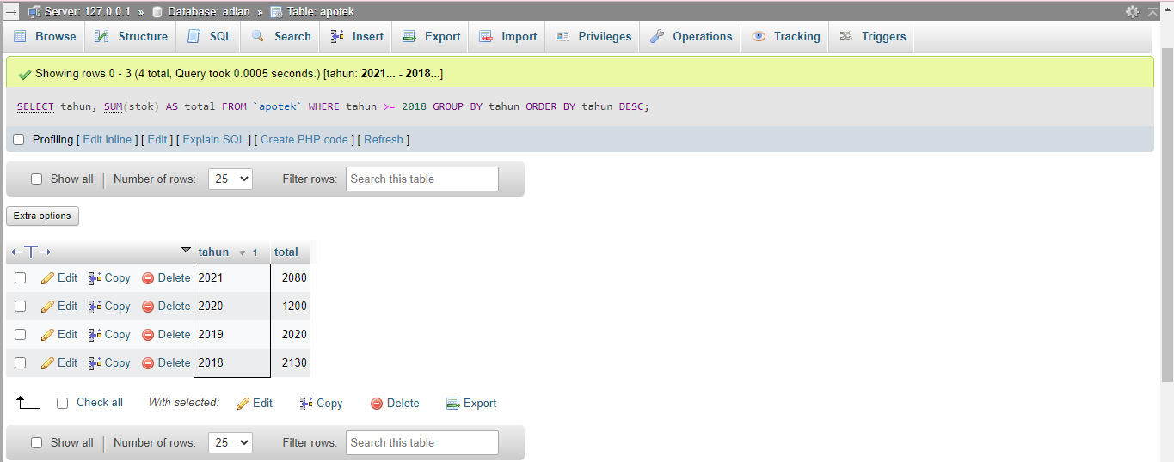

1. **SELECT jenis_produk, SUM(stok) AS total FROM ‘apotek’ GROUP BY jenis_produk ORDER BY jenis_produk ASC**

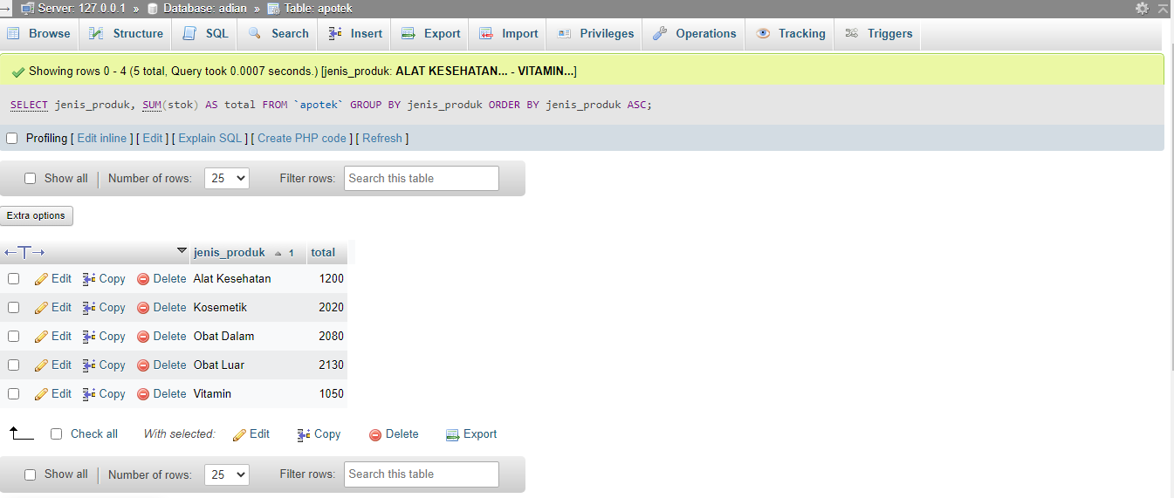

1. **SELECT jenis_produk, SUM(stok) AS total FROM ‘apotek’ GROUP BY jenis_produk ORDER BY jenis_produk DESC**

